KaMCOP FEC Baseline Survey 2022/23 – SAMPLE COPY

This is a sample only which shows the full content of the survey and is NOT to be printed for students to complete. All surveys are to be completed using the online link:
bit.ly/FEBase22

FE College Baseline Survey 2022/23 - Introduction

KaMCOP (Kent and Medway Collaborative Outreach Programme) is a project that is funded to support the aspirations and attainment of people that may not otherwise consider going to university or higher education (HE – level 4 courses+). You can find out more about KaMCOP here.

We are funded by a government organisation called the Office for students (OfS) and we are collecting data in this survey to help ensure that the work we do has a positive impact on students (you!).
The survey includes sections on your thoughts about education, university and your current plans for the future.

Privacy Notice
How we use and manage your data
We need to show that the work we do has a positive impact on the students that we work with by monitoring data for a prolonged period of time (around 15-20 years). In order to do this, we will ask you to provide information such as your name, college, sex, date of birth and post code. You will not be asked for any contact details, and therefore will never be contacted as a result of this survey.

We may share your data with educational agencies so that we can track the journey and destinations of the young people we work with.

You do not have to provide your details if you do not want to, but we would be grateful if you could allow us to use this information so that we can continue to develop activities for students like you.

Please read through the full privacy notice by following this link KaMCOP FEC Survey Privacy Notice.pdf if you would like more information, including agencies who may access your data and how your data will be used.

- I confirm that I have been given the opportunity to read the privacy notice and understand how my personal data is used
- I don't want to enter my personal data

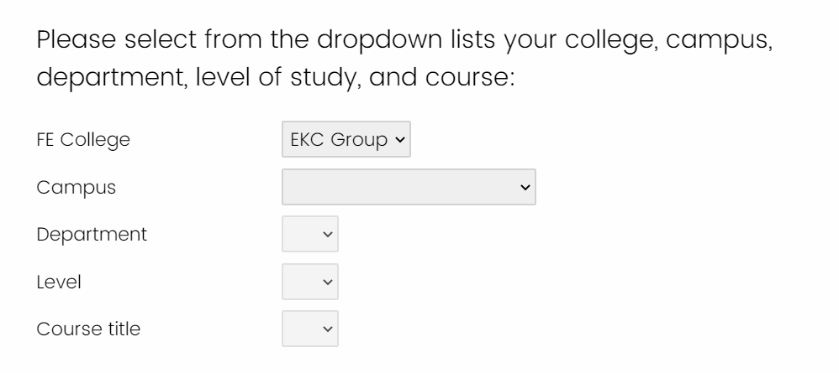

If you are studying a Level 3 course, which year of study are you in?
- Year 1
- Year 2

Your Details
- First Name ________________________________________________
- Surname ________________________________________________
- Home Postcode (e.g. AB12 3CD) ________________________________________________
- Date of Birth (e.g. for 1st February 2003, enter 01/02/2003) ____________________________

Your sex
- Male
- Female
- Other ________________________________________________

What is your student ID number?

If you go on to Higher Education, would you be the first generation of your immediate family to go? (that is, neither of your parents/carers went into HE)
- Yes
- No
- Don't know

Do you have a disability, learning difficulty or long-term physical or mental health condition?
- Yes
- No
- Prefer not to say

What is your ethnic group? Please tick the box below to indicate your cultural background
- White - British
- White - Irish
- White - Scottish
- White
- Gypsy or Traveller
- Irish Traveller
- Other White background (add below) ________________________________________________
- Asian or Asian British - Bangladeshi
- Asian or Asian British - Indian
- Asian or Asian British - Pakistani
- Other Asian background (add below) ________________________________________________
- Chinese
- Arab
- Black or Black British - African
- Black or Black British - Caribbean
- Other Black background (add below) ________________________________________________
- Mixed - White and Black African
- Mixed - White and Black Caribbean
- Mixed - White and Asian
- Other mixed background (add below) ________________________________________________
- Other ethnic background (add below) ________________________________________________
- Prefer not to say

___________________________________________________________________________

The following questions aim to find out about your attitudes towards education.

When you finish your current level of studies, what would you most like to do next?
- Get a job
- Get an apprenticeship
- Stay on at college
- Go to university
- Study higher education at college
- Get a higher/degree apprenticeship
- Take a gap year
- Undecided or Don't know
- Other ________________________________________________

What GCSE (or equivalent) grades did you get?

 | Yes | No | Don't know | Prefer not to say
I achieved at least 5 GCSEs of between 4 (C) and 9 (A*)
I achieved at least a 4 (C) in my English GCSE
I achieved at least a 4 (C) in my Maths GCSE

How much do you agree with the following statements about your future?

 | Strongly agree | Agree | Don't agree or disagree | Disagree | Strongly Disagree
I am motivated to do well in my studies
I am confident I could get the grades I need for further study
I am confident I could gain a place on a course of my choice if I wanted to
I know what I need to do to achieve my career aspirations
My parents/guardians expect me to go on to study in Higher Education

How much do you know about the following aspects of Higher Education study? (HE is all Level 4 or above courses in University or in a Further Education College)
 | A lot | Quite a bit | A little |  | Very little | Nothing
How HE qualifications can lead to careers you are interested in
The qualifications & grades to get into the course you want
Where to find information about applying
Different routes (e.g. apprenticeships, distance learning, or HE in an FE setting)
The different courses that are available
Student finance and cost of studying
Other types of support available (e.g. advice and guidance, mental health)
What student life would be like
Where to find out more about HE

How much do you agree with the following statements about Higher Education?

 | Strongly agree | Agree | Don't agree or disagree | Disagree | Strongly disagree
It is for people like me
I would fit in well with others
I have the academic ability to succeed
I could cope with the level of study required
It will improve my social life

How likely are you to apply to Higher Education in the future?
- Definitely will apply
- Very likely
- Fairly likely
- Don't know
- Fairly unlikely
- Very unlikely
- Definitely won't apply

The following questions aim to find out how you view your personal character and feelings.

Please indicate how much you agree with the following statements:
 | Strongly Agree | Agree | Don't Agree or Disagree | Disagree | Strongly Disagree
I have a clear understanding of who I am
I have a clear idea about what I want to do in the future
I know how to make plans to achieve my goals
I can use techniques to manage my time effectively
I think I will be happy in the future
I will be successful in the future
I can positively present myself to others
I feel that I have a number of good qualities
I am able to do things as well as most other people
Setbacks do not discourage me
I feel good about myself
I am responsible for what happens to me

Many thanks for completing this survey! Please click the button to submit your results.

